Day 55 – Full Adder and Full Subtractor Using DEMUX

Introduction:A Demultiplexer (DEMUX) is a combinational circuit that routes a single input to one of multiple outputs based on the select lines.

1. Full Adder Using DEMUX

Design: A Full Adder is a combinational circuit that adds three single-bit binary inputs: A, B, and Carry-in (Cin). It produces two outputs: Sum and Carry-out (Cout).
Boolean Expressions:Sum = A ⊕ B ⊕ Cin Cout = AB + ACin + BCin.
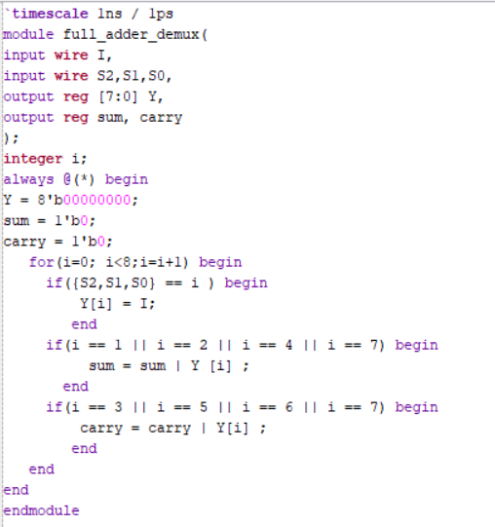

Testbench: The testbench applies all eight combinations of the three select inputs to verify the Sum and Carry-out outputs with the DEMUX input set to HIGH.

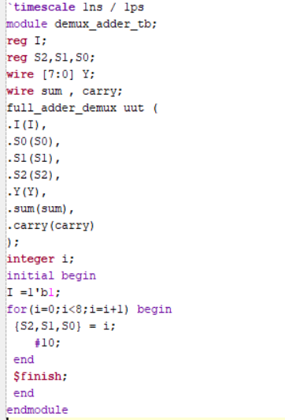

Waveform: The waveform verifies that the Sum output is HIGH when an odd number of inputs are HIGH. The Carry-out output is HIGH when at least two of the three inputs are HIGH.

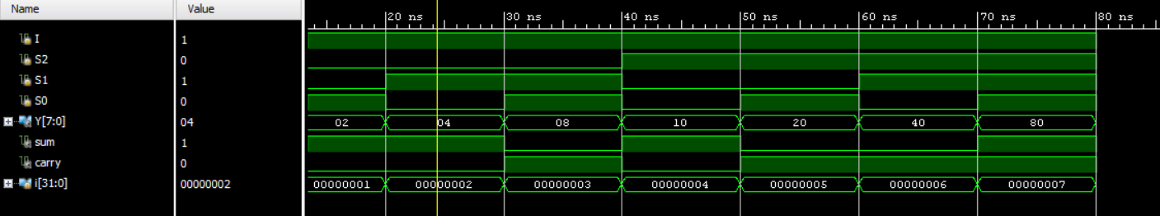

Schematic: The RTL schematic of the Full Adder implemented using DEMUX is generated and analyzed using Xilinx Vivado.

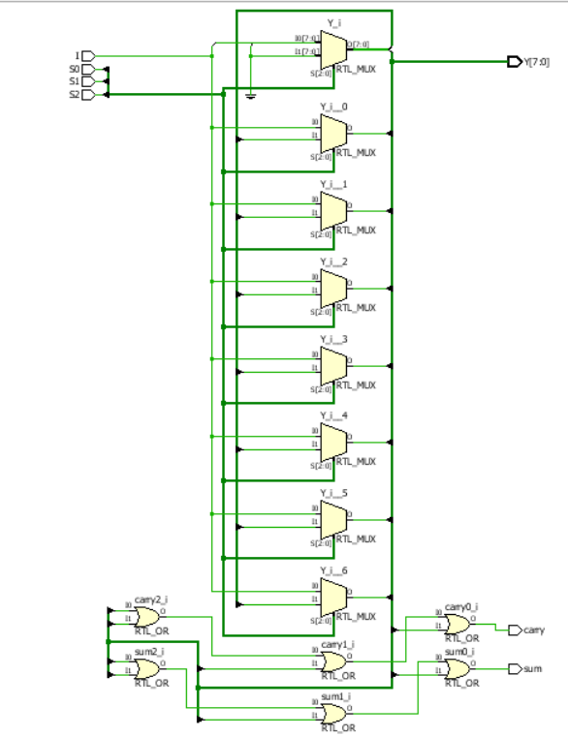

2. Full Subtractor Using DEMUX

Design: A Full Subtractor is a combinational circuit that subtracts two single-bit binary inputs, A and B, along with Borrow-in (Bin). It produces two outputs: Difference and Borrow-out (Bout).

Boolean Expressions: Difference = A ⊕ B ⊕ Bin Bout = A'B + A'Bin + BBin.

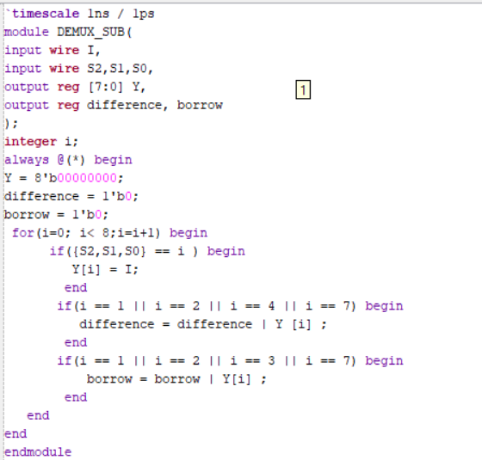

Testbench: The testbench applies all eight combinations of the three select inputs to verify the Difference and Borrow-out outputs with the DEMUX input set to HIGH.

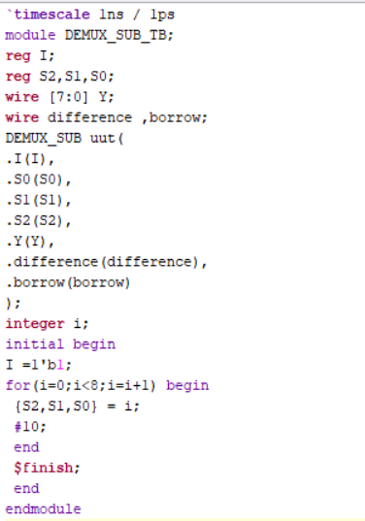

Waveform: The waveform verifies that the Difference output is HIGH when an odd number of inputs are HIGH. The Borrow-out output is HIGH when the value being subtracted, including Borrow-in, requires a borrow from the next higher bit.

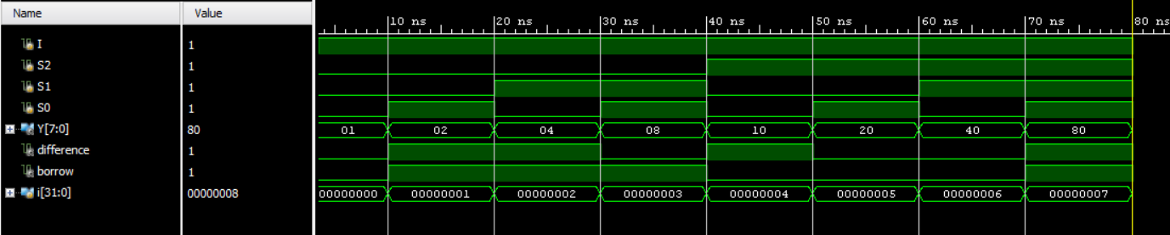

Schematic: The RTL schematic of the Full Subtractor implemented using DEMUX is generated and analyzed using Xilinx Vivado.

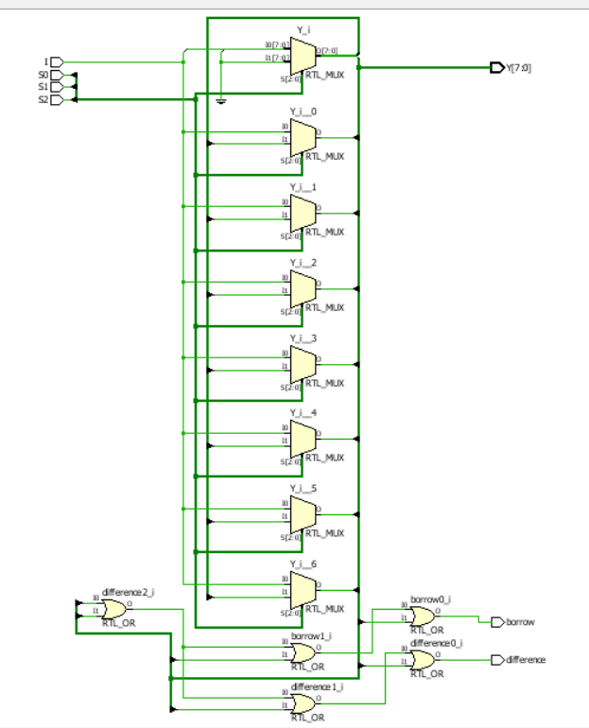

Observation
The Full Adder and Full Subtractor were implemented using DEMUX-based logic and verified through simulation. This experiment improved my understanding of binary arithmetic, Boolean expressions, minterm-based logic implementation, and combinational circuit design using Verilog HDL.

#PHANEENDRA.SINGUDASU

